Real Estate Project Layout

Home/Landing Page

Header Section:

LOGO 🔍 Search bar Rent Buy About Services Contact Us

Banner Section:

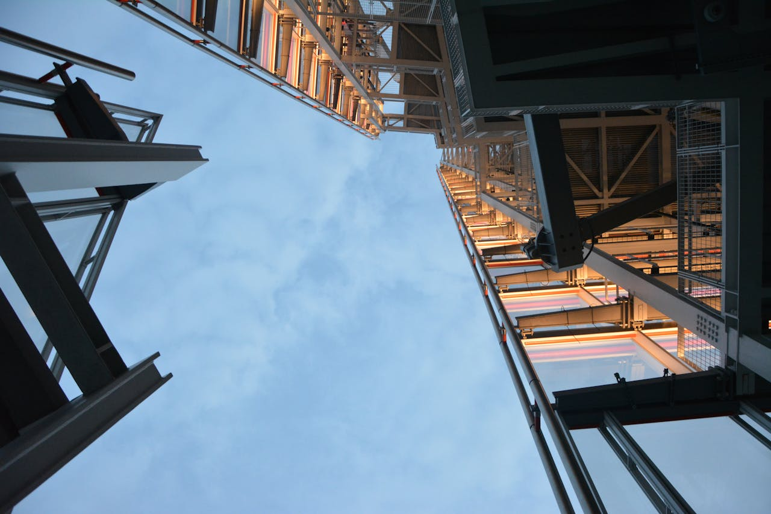

Hero Section:

“We Build Your Vision”

The Broadstone is a meticulously designed sanctuary offering a premium living central to one's life. Holding comfort and convenience at their heart, the two towers' modern, slick exteriors feature clean lines and muted colours. And these premium apartments come with well-thought-of features finished to the highest standards.

At **Stone Edge Constructions**, we specialize in turning your vision into reality. With over 15 years of experience in the construction industry, we are known for our attention to detail, timely delivery, and unmatched craftsmanship.

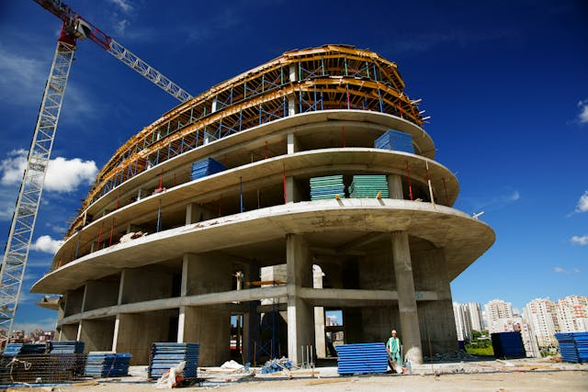

Featured services:

Residential and Commercial Plots listed

Footer Section:

Contact Details: 📞 📍 ✉️ Copyrights and social media handles

About Us Page

Company Overview:

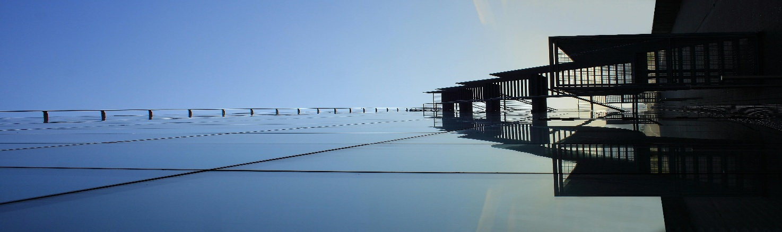

At **Our Constructions**, we don’t just build structures — we build trust, reliability, and long-lasting relationships. With over **15 years of experience** in the construction industry, we have established ourselves as a leading name in **residential, commercial, and industrial** construction services across India.

Our Mission

***To offer reliable, efficient, and sustainable construction solutions that exceed client expectations in terms of quality, safety, and timely delivery****.*

Our Vision

***To be a top-tier construction company recognized for excellence in craftsmanship, transparency, and innovation.***

Achievements:



✔️ 300+ Projects Delivered On-Time

✔️ ISO Certified Quality Standards

✔️ Skilled In-House Engineers & Technicians

✔️ Transparent Communication & Reporting

✔️ Turnkey Project Execution & Cost Control

✔️ Focus on Safety, Sustainability, and Innovation

Licence and Certifications:

Footer Section:

Contact Details: 📞 📍 ✉️ Copyrights and Social media handles

Services Page:

🔍 Search bar / Filter Options :

Residential/Commercial Plot sales Lists:

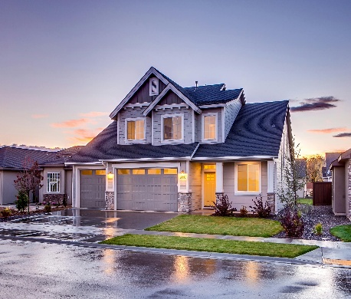

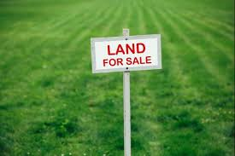

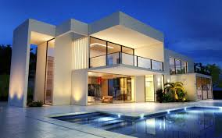

Details: Details: Details:

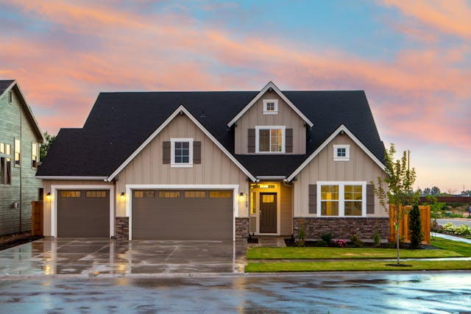

Details:



Details:



Details:

Other Services:

* + Land Development
  + Land Registration
  + Legal Documentations
  + Raw Materials for Construction

Footer Section:

Contact Details: 📞 📍 ✉️ Copyrights and social media handles

Contact Page:



**We’d love to hear from you! Whether you’re planning a new project, looking for a construction partner, or simply have questions — our team is here to help.**

Contact Form:

NAME

MOBILE

EMAIL

SERVICE TYPE (dropdown)

**Hell0 Constructions Pvt. Ltd.** Google Map: (If Needed)  
Plot No. 45, Sector 12A,  
, Chennai – 000000  
📞 Phone: +91-98654343  
✉️ Email: contact@helloconstructions.in

Footer Section:

Contact Details: 📞 📍 ✉️

Copyrights and social media handles